SDLC / STLC

Creare release and cycles

https://www.youtube.com/watch?v=jzhgAefdXEA

Definire cerinte

https://www.youtube.com/watch?v=GWAUmhiReg0

Conversia cerintelor in teste

https://www.youtube.com/watch?v=FZtELBHPaeg

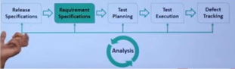

Rularea unei instante

https://www.youtube.com/watch?v=8ngpVWPzQo8

HP ALM TUTORIALS (68 tutoriale)

https://www.youtube.com/watch?v=sycBQAQ-0Aw&list=PLWPirh4EWFpGBLHMwVxI-luLa7iAVB1NB webografie

https://www.guru99.com/hp-alm-free-tutorial.html

UTM

https://www.youtube.com/watch?v=mEcqvIV-m2Q